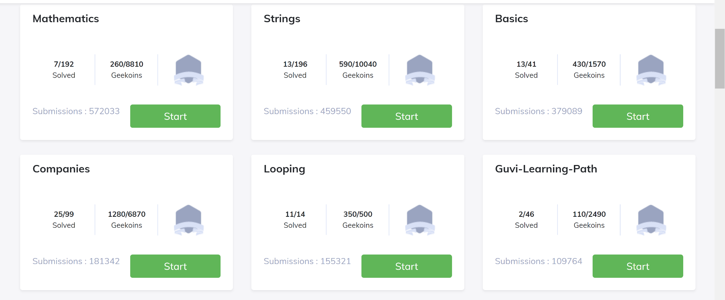

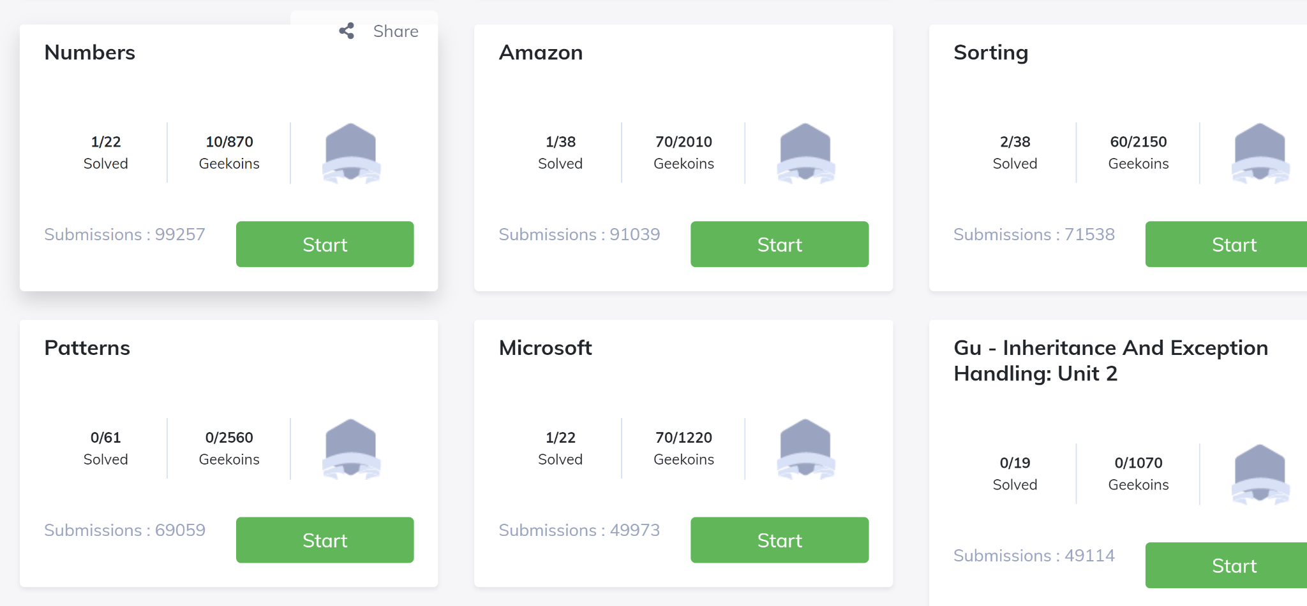

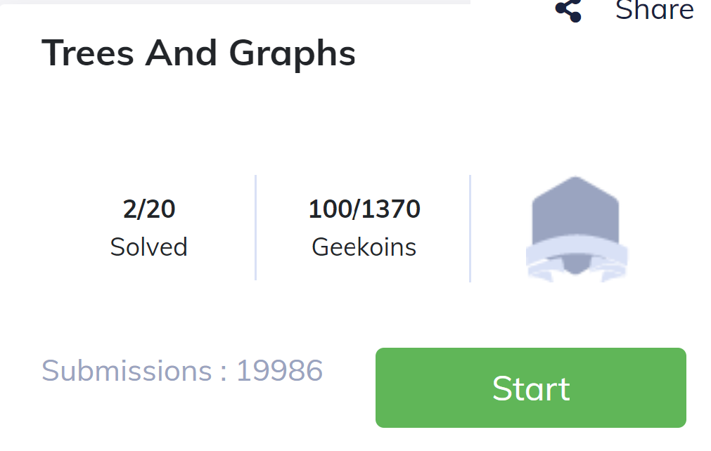

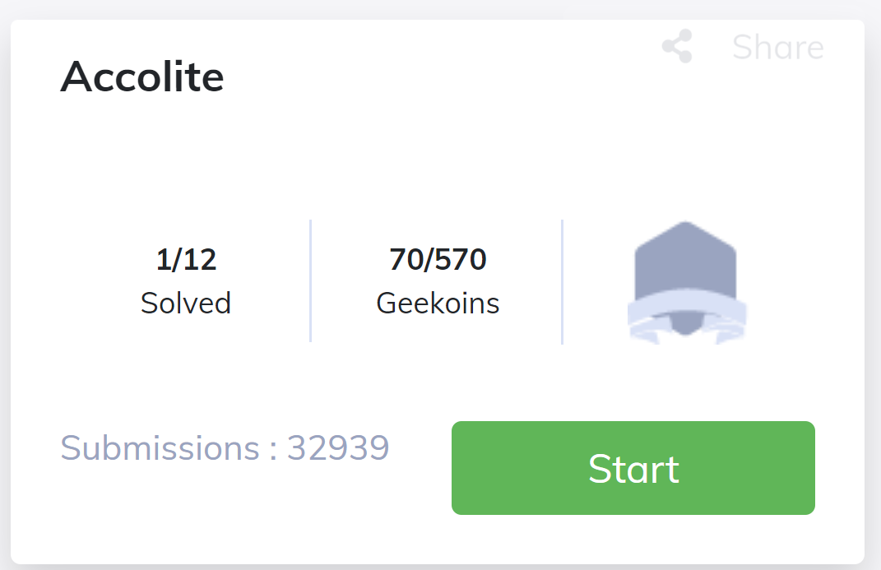

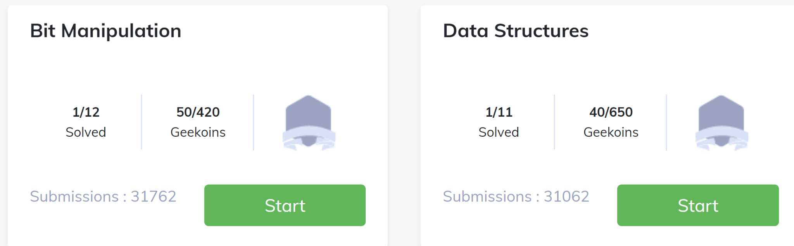

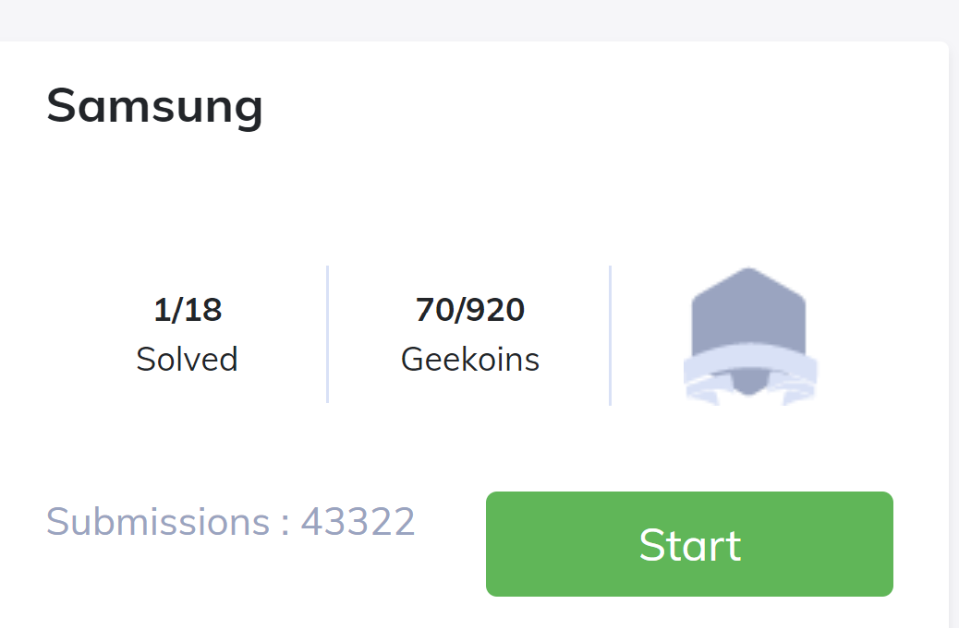

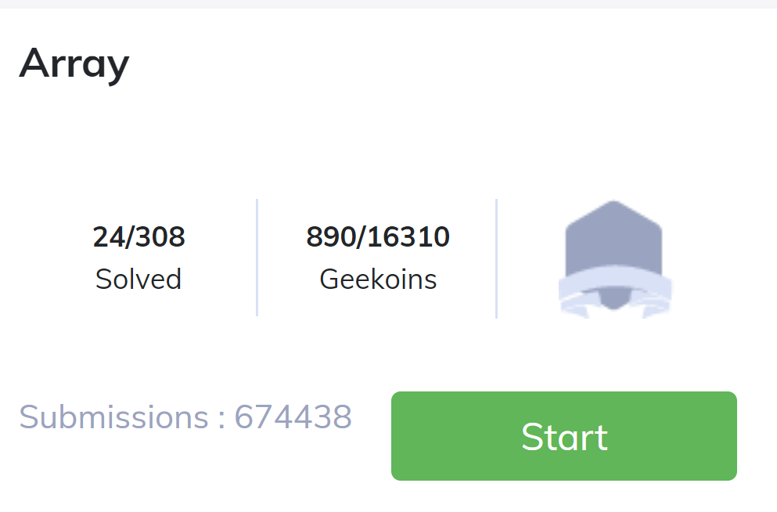

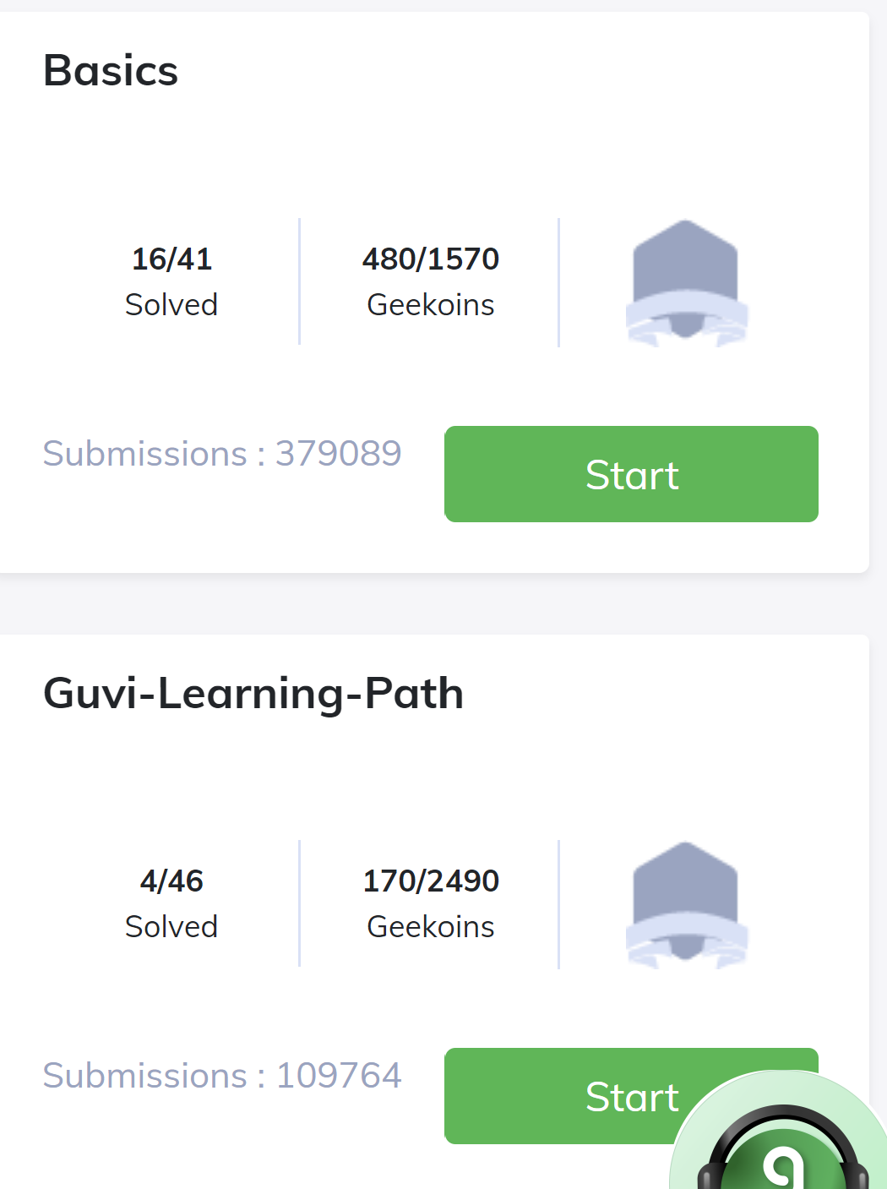

Companies- 10

Array-8

Strings-6

Maths-3

Basics-8

Samsung-1

Data structures-1

Bit manipulation-1

Accolite-1

Trees and graphs-2

Amazon-1

Microsoft-1

Numbers-1

Sorting-1

Guvi-2

Looping-5 Total 52